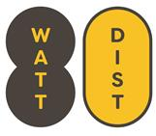
80 Watt District
Board of Directors Meeting
Thursday, JULY 8, 2021 @ 11:00 am-12:30 pm
TELECONFERENCE-due to COVID-19
Join Zoom Meeting
https://us02web.zoom.us/j/82188822119
Meeting ID: 821 8882 2119
Find your local number: https://us02web.zoom.us/u/kbtTF3FAFf
VIDEO & PHONE CONFERENCE (with App)

AGENDA

Please be advised that the Regular Monthly Meeting of the Board of Directors for the 80 Watt District, scheduled for Thursday, July 8, 2021, at 11:00 a.m. is dark for the month of July. CANCELLED

The next regular monthly meeting of the 80 Watt District, is scheduled for Thursday, August 12, 2021, @ 11:00 am.

